Special Report

Guam’s Coconut Rhinoceros Beetle Problem: Past, Present and Future

Invasive Species are a Crisis for Guam, Right Now!

By Aubrey Moore, University of Guam

Many people know about extinction of Guam’s birds by the brown tree snake which invaded the island shortly after World War II. But the contemporary ecological disaster currently playing out in Guam’s forests is not as well known: our trees are dying.

It’s estimated that 90 percent of Guam’s endemic cycads, locally known as *fadang*, have been killed by a coalition of recently-arrived invasive insects, including a scale insect, a leaf-mining moth and a defoliating butterfly. Fadang was listed as being the most abundant tree in Guam’s forests in a 2002 forestry survey, but then added to the National Endangered Species List in 2015.

A pretty dramatic change.

The same 2002 survey listed coconut palm as the second most abundant tree on the island, yet in recent years, many coconuts and other palms on Guam have been severely damaged and killed by the coconut rhinoceros beetle. There is no estimate for the proportion of palms killed but it’s obvious to residents and visitors that the island’s palms are being killed at an alarming rate.

Pix beetle

The rhino beetle is native to southeast Asia and like all beetles, has four life stages: egg, grub, pupa, and adult. Only the adult stage causes damage as adult males and females bore into the crowns of coconut palms and other palms to feed on sap. Each adult feeds on sap for only a few days and then leaves the crown to search for a breeding site. Palms may be killed if a CRB bores through the growing tip (the meristem). Mature palms are rarely killed at low CRB population levels. However, trees are killed when they are simultaneously attacked by many adults during a population outbreak such as the one we are currently experiencing on Guam.

Pix life cycle

CRB breeding sites can be found in any mass of decaying vegetation. Preferred sites are standing dead coconut stems and fallen coconut logs and fronds. But piles of anything with a high concentration of decaying vegetation can be used as a breeding site including green-waste, dead trees of any species, saw dust and manure. CRB breeding sites have even been found in commercially bagged soil purchased from a local hardware store. An active breeding site will contain all CRB life stages. Adults locate breeding sites by sniffing out a chemical signal referred to as an aggregation pheromone.

A female rhino beetle lays about 100 eggs during her lifetime. Assuming a 50 percent sex ratio and 100 percent survival, there will be a population increase of 5,000 percent during each generation. Thus population explosions may occur when abundant potential breeding sites are available in the form of rotting vegetation following destruction in the wake of a typhoon, large scale land clearing, or war. This positive feedback cycle will end only when the rhino beetles run out of food, meaning when most of the palms have been killed and rotted away.

CRB invaded islands in the Pacific and Indian oceans during two waves of movement. The first wave occurred started in 1909 when CRB was accidentally transported from Sri Lanka to Samoa with shipment of rubber tree seedlings and it ended during the 1970s. Other invasions occurred in the Ryukyu Islands (Okinawa) in 1921 and in Palau (1942) as war activities created abundant breeding opportunities.

Next up Guam (2007), Hawaii, Papua New Guinea, Guadalcanal, the Solomon Islands and Rota.

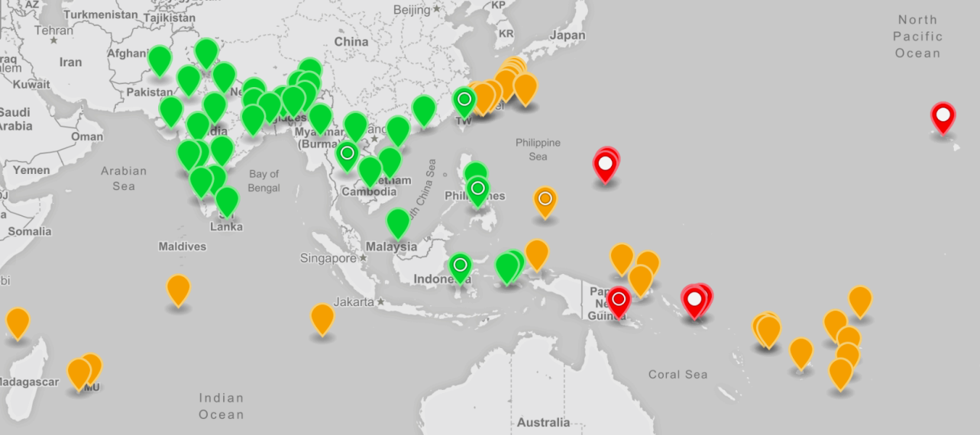

Distribution of coconut rhinoceros beetle, Oryctes rhinoceros. Green markers: native range; Brown markers: first detected in the 20th century; Red markers: first detected in the 21st century; Open circle: population includes CRB-G biotype; Filled circle: population is exclusively CRB-G biotype. An interactive version of this map is available online at <http://aubreymoore.github.io/crbdist/mymap.html>.

# Guam CRB Eradication Program

After the CRB was spotted on Guam in 2007, an island-wide survey located grubs and adults and damage symptoms only in Lower Tumon and at the adjacent Faifai Beach, an area totaling less than 1,000 acres . Based on this information it was decided that eradication would be attempted, meaning killing every single CRB on the island.

In theory, a CRB population can be eradication from an island by locating and destroying all active breeding sites and ensuring that the arrival pathway is blocked to prevent re-infestation. In practice, CRB eradication is difficult. There have been several CRB eradication attempts, but only one of these was successful. CRB was eradicated from Niuatoputapu Island, also known as Keppel Island, a tiny outer island of Tonga, only 16 square kilometers in area. Eradication was accomplished by a sanitation program which lasted nine years following first detection of CRB in 1921 .

The Guam CRB Eradication Project was a joint effort involving the United States Department of Agriculture, the Guam Department of Agriculture and the University of Guam. Financial support came from the United States Department of Agriculture, the United States Forest Service and the Legislature of Guam. The project used several tactics aimed at wiping out the CRB population: quarantine, sanitation, trapping, and chemical control.

## Quarantine

Unfortunately, despite a quarantine on transport of dead vegetation to other parts of the island, the infestation spread from the Tumon Bay area to breeding sites prior to 2010. Most breeding sites are currently inaccessible for application of eradication tactics, being in the deep jungle and/or on military property which includes about one third of the island.

## Sanitation

Sanitation is the most important tactic in any CRB eradication project. The target is to find and destroy all breeding sites before adults are generated, thus halting reproduction preventing all damage. The eradication program employed four detector dogs trained to sniff out rhino beetle grubs.

## Trapping

At the start of the eradication project, we were advised that the adult population could be annihilated using the commercially available aggregation pheromone as a lure, but we soon learned that the traps were ineffective for population suppression when new damage appeared in mass trapping areas. However, an island-wide trapping network of about 2,000 traps was useful for monitoring the spread and growth of the CRB population. Island-wide trapping was discontinued when Typhoon Dolphin visited the island in May 2015.

We improved the pheromone traps, but they still catch only about 25 percent of adult beetles. This is not high enough for effective population suppression under current conditions. During our CRB trap improvement project, we discovered that local fishermen were using a small fish gill net called *tekken* to capture CRB adults emerging from compost piles. This has become a useful tool for managing CRB. Tekken captures about 65 percent of adults attempting to leave infested compost or green-waste piles. What may be more important is that these same piles become attractive to incoming adults which are also trapped.

## Chemical control

Individual palms can be protected from CRB attacks by prophylactic insecticide application. But this is very expensive. A row of 33 severely damaged coconut palms at the University of Guam Agricultural Experiment Station in Yigo were nursed back to apparent perfect health by spraying their crowns with the insecticide cypermethrin on a biweekly schedule. It took 15 months of treatment before all damaged fronds were replaced by healthy ones.

# Guam CRB Biological Control Program

In their native environment, insect populations are suppressed by natural enemies which include parasites, predators and pathogens. When alien insects invade islands they escape control by natural enemies, resulting in damaging population explosions. Biological control programs introduce bio-control agents which specifically target invasive species. The Guam program, using a virus called *Oryctes rhinoceros* nudivirus (OrNV) and a fungus called *Metarhizium majus* started after the eradication program failed. Both of these pathogens attack only rhino beetles and pose no risk to other organisms.

# Typhoon Dolphin Triggers a CRB Population Explosion

When we thought that the Guam CRB problem could not get worse, it did. Typhoon Dolphin in 2015 triggered the current CRB outbreak we are experiencing.

Typhoon Dolphin was not a very strong typhoon by Guam standards, but it was the first one in more than a decade and it created a lot more damage than expected. Abundant piles of decaying vegetation became CRB breeding sites. Some of these new breeding sites were in villages where they could be managed. But most were inaccessible: in jungles and/or on military land. Within a few months, massive numbers of adults were emerging from breeding sites and severely attacking palms which started to die. Prior to Dolphin, we saw some heavily damaged palms, but very few dead ones. Once a palm is killed, its dead standing trunk becomes an excellent breeding site which eventually produces even more adults, resulting in a self-sustaining outbreak such as the one we are experiencing.

# Where do we go from here?

If we do not control the current rhino beetle outbreak on Guam, it will only end when the beetles run out of food. Which means most of Guam’s palm trees will be killed, as happened in Palau after WW II. If current outbreaks in the Pacific cannot be suppressed, it is only a matter of time until this biotype invades other islands through accidental transport. If CRB-G (Guam genetic variety) reaches atolls where the coconut palm is *the tree of life* this will be a human tragedy, possibly displacing islanders to larger population centers.

At the 2016 International Congress of Entomology, the USDA sponsored a meeting to plan a regional response to CRB-G. Pacific-based entomologists with extensive experience working with CRB agreed that our best bet for stopping CRB-G outbreaks is to find an effective biocontrol agent for CRB-G. Most likely this will be an isolate of OrNV which is highly pathogenic for CRB-G. Although a regional project has yet to be funded and organized, the search has already begun. The University of Guam has been awarded a grant from USDA-APHIS to collaborate with rhino beetle bio-control experts at AgResearch New Zealand and another grant from Department of the Interior’s Office of Island Affairs will fund a post-doc entomologist to work on this project.

Pix CRB damage (see below)

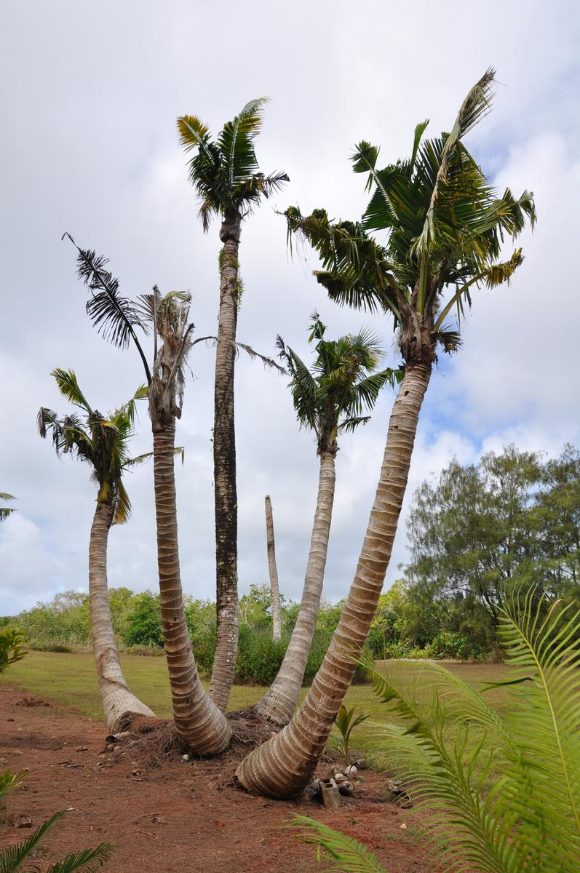

[fig:CRB-damage]Coconut palms at the University of Guam Agricultural Experiment Station in Yigo severely damaged by coconut rhinoceros beetle.